UNIVERSITY OF RWANDA
COLLEGE OF SCIENCE AND TECHNOLOGY
SCHOOL OF ICT
COMPUTER AND SOFTWARE ENGINEERING DEPARTMENT
NYARUGENGE CAMPUS
MODULE CODE/TITLE: WEB DESIGN
PROJECT TECHNICAL REPORT
Web Technology Technical Assessment 2026
PROJECT TITLE:
CAMPUS SYNC
A Free Online Learning Platform for Programming, Business, Language and Web Design
Prepared by: [Your Full Name]
Registration Number: [Your Registration Number]
Year of Study: Year One
Submitted to: [Lecturer's Name]
Date: [Submission Date]

Table of Contents

Table of Figures
Figure 1: Campus Sync – High-Level Architecture (Static Front-End)
Figure 2: Campus Sync – Home Page UI Sketch (Wireframe)
Figure 3: Campus Sync – Site Navigation Flowchart

List of Abbreviations
- HTML – Hyper-Text Markup Language
- CSS – Cascading Style Sheets
- JS – JavaScript
- UI – User Interface
- UX – User Experience
- DOM – Document Object Model

Chapter 1. Introduction

1.1. Historical Background of the Case Study
Access to quality learning material is not always easy for students who want to learn new skills such as programming, business, languages, web design, or artificial intelligence. Many existing platforms are either too expensive, too advanced for beginners, or not well organized. Campus Sync was imagined as a simple, student-friendly website that brings different free learning topics together in one place, making it easier for beginners to start learning without confusion or cost.

1.2. Problem Statement
Beginner learners, especially students who are new to a subject, often struggle to find a single, simple, and organized website where they can see different course categories (programming, business, language, design, AI) clearly laid out. Most available resources are scattered across many different websites. Campus Sync addresses this by presenting a clean, easy-to-navigate front-end website where a learner can quickly browse course categories from one homepage.

1.3. Objectives of the Project
General Objective:
To design and build a simple, responsive website front-end that presents free online courses in programming, business, language, web design, and artificial intelligence.
Specific Objectives:
- To design a clean and responsive homepage using HTML and CSS.
- To create a course listing page that displays different course categories.
- To use basic JavaScript to add simple interactivity (e.g. menu toggle, button actions).
- To ensure the website is easy to navigate on both desktop and mobile screens.

1.4. Expected Outcomes
At the end of the project, a fully working static website (HTML, CSS and JavaScript only) is expected, with a homepage, a courses page, an about page and a contact page, all linked together and styled consistently.

1.5. Project Rationale (Importance to the Community)
Campus Sync is important because it gives beginner learners, including secondary school leavers and first-year university students, a simple starting point to explore different free skills in one organized place, encouraging self-learning and digital literacy within the community.

Chapter 2. System Analysis and Design

2.1. System Analysis

2.1.1. Intended Users of the Project
- Beginner students who want to learn programming, business, language, web design, or AI basics.
- Visitors browsing available free course categories.
- The lecturer/assessor reviewing the project for the Web Design module.

2.1.2. Intended System Partners
Not applicable at this stage. Campus Sync is a standalone front-end project built only with HTML, CSS and JavaScript. It does not connect to any back-end service, external API, or partner organization.

2.2. System Design

i. High-Level Architecture
Since Campus Sync has no back-end or database, the architecture is simple: the user's browser loads static HTML pages styled with CSS, and JavaScript handles small interactive behaviours such as menu toggling and navigation, as shown in Figure 1.
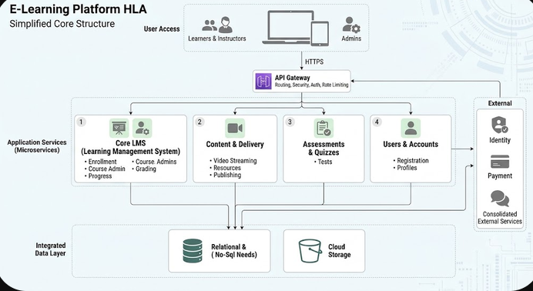

Figure 1: Campus Sync High-Level Architecture (Static Front-End)

ii. UI Design (Sketch of the UI Module) and Flowcharts
Figure 2 shows a wire-frame sketch of the homepage layout, including the navigation bar, hero banner, and the featured course category cards (Programming, Business, Language, Web Design, and Artificial Intelligence).
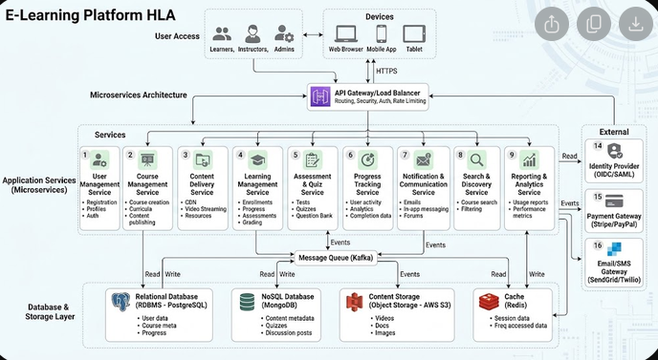
Figure 2: Campus Sync Home Page UI Sketch (Wireframe)
Figure 3 shows how a user navigates between the pages of the website, starting from the Home page.

Figure 3: Campus Sync Site Navigation Flowchart

iii. Database Design with Entity Relationship Diagram and Relationships
Not applicable. Campus Sync, in its current version, is a static front-end website built only with HTML, CSS and JavaScript. It does not use a database. Course information displayed on the Courses page is written directly into the HTML, or optionally stored in a simple JavaScript array, for demonstration purposes only.
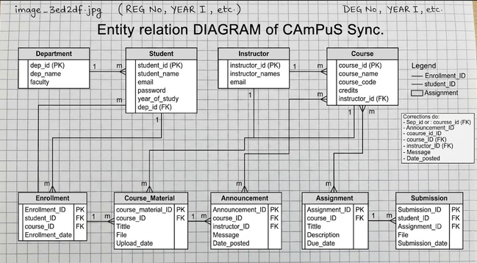

Chapter 3. Implementation

3.1. Introduction of the Section
This chapter presents screenshots of the implemented Campus Sync website pages, together with a short discussion of each page's purpose and how it was built using HTML, CSS and JavaScript. Replace the placeholders below with your own screenshots once your pages are ready.

3.2. Home Page FOR CAMPUS SYNC

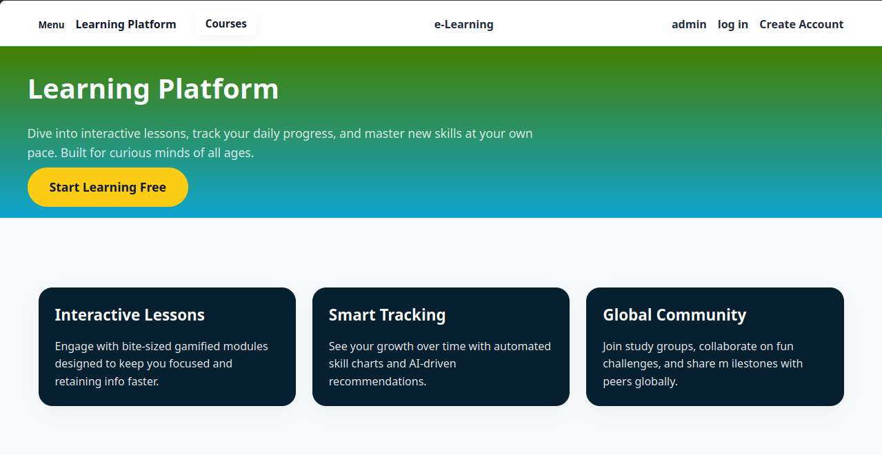

The Home page introduces Campus Sync with a navigation bar, a welcome banner, and cards linking to the main course categories. It was built using semantic HTML5 elements and styled with CSS Flex-box/Grid for a responsive layout.

3.3. Courses Page
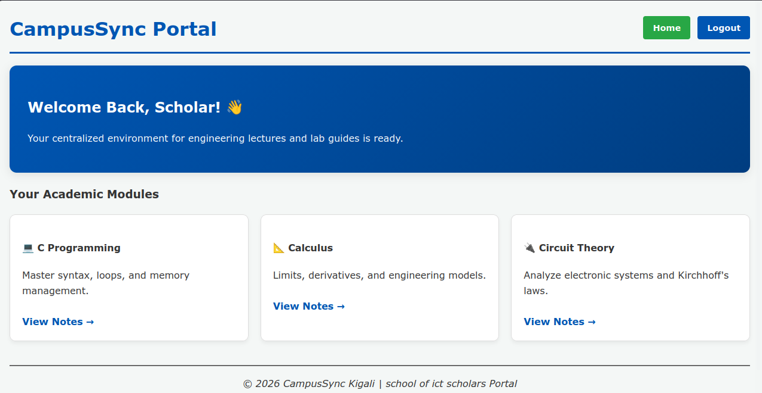

The Courses page lists the available free course categories (Programming, Business, Language, Web Design, Artificial Intelligence) using styled cards. Basic JavaScript may be used to filter or highlight a selected category.

3.4. About Page

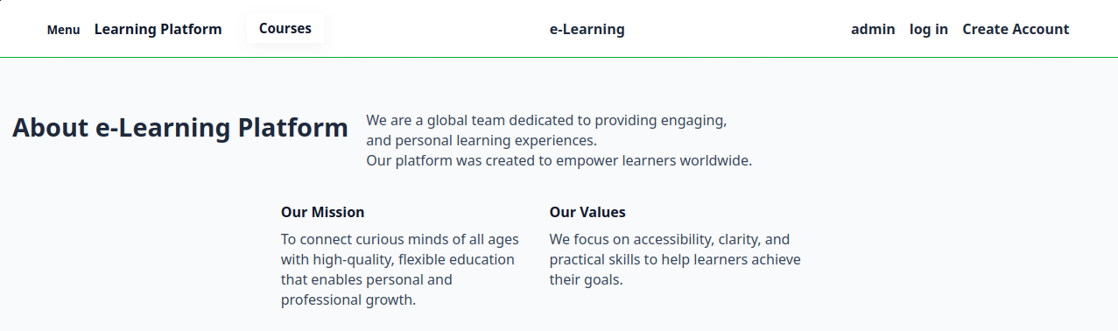

The About page explains the purpose of Campus Sync and who it is designed for, giving visitors context about the project.

3.5. ADMINISTRATOR PAGE

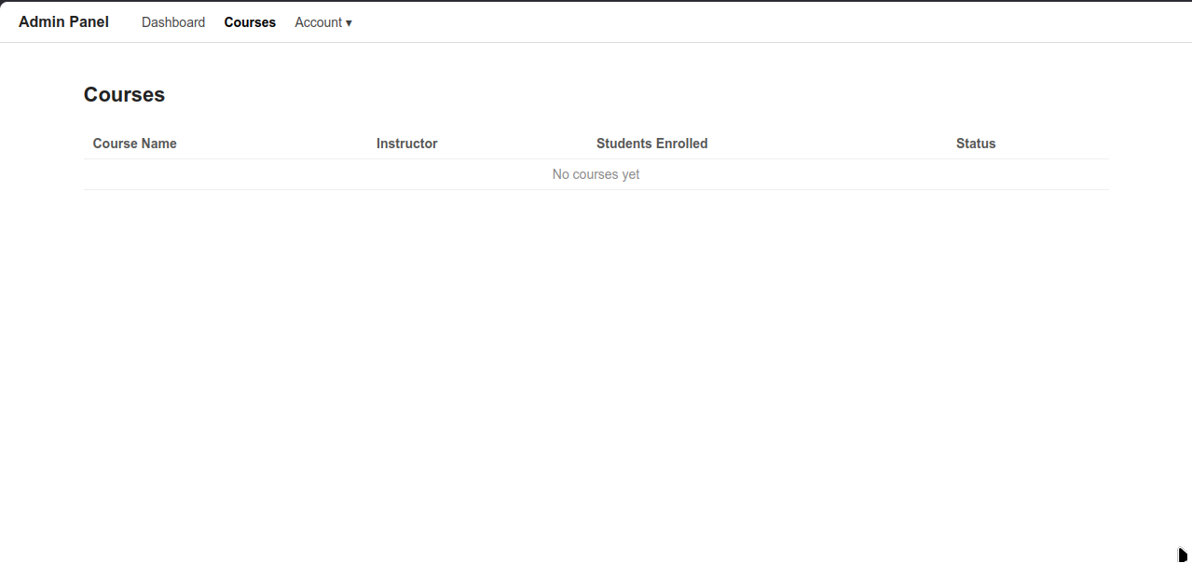
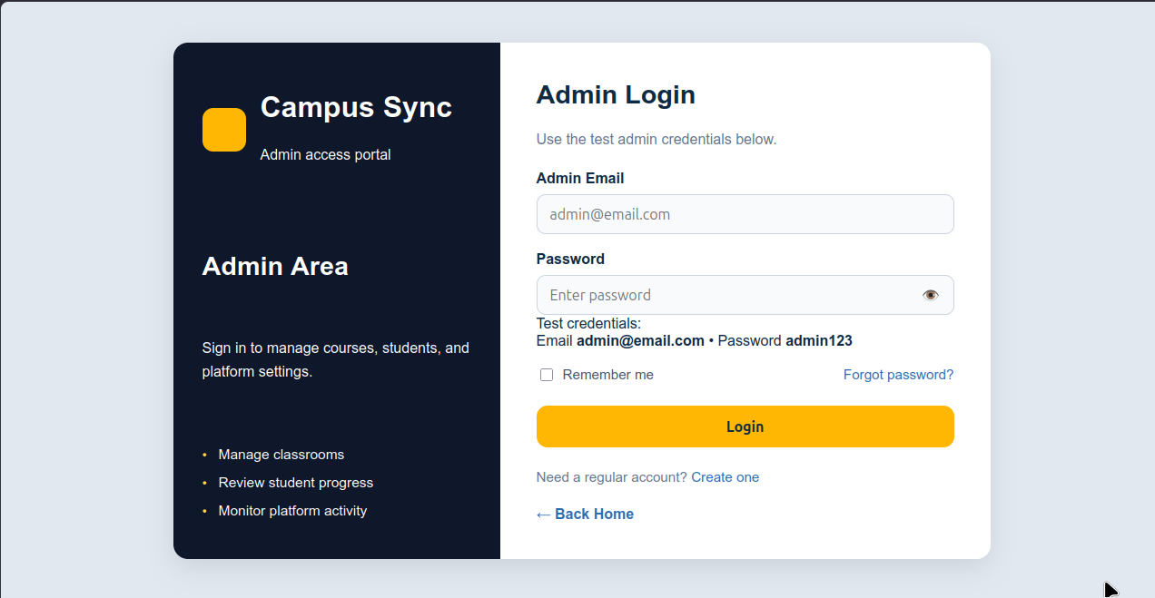

3.6. CREATING NEW ACCOUNT AND LOGIN ACCOUNT

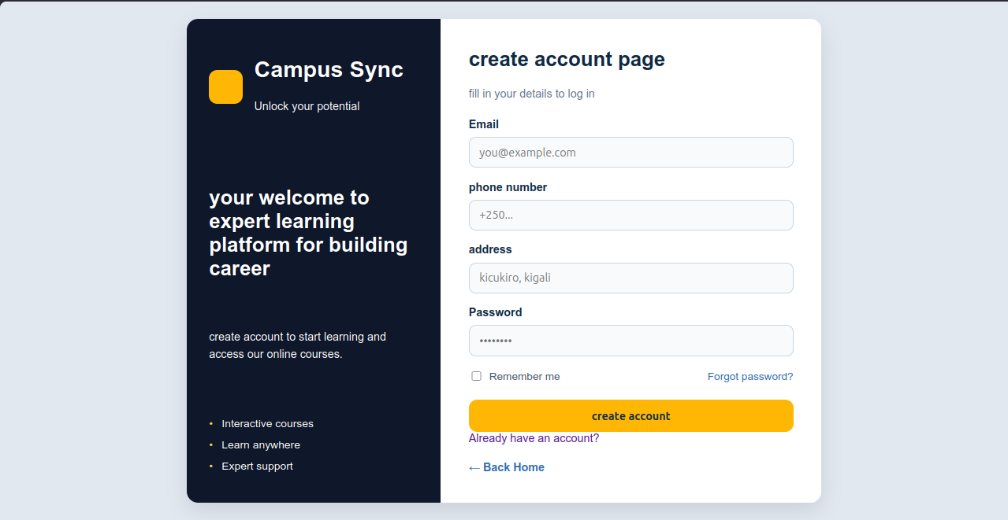
A simple JavaScript function toggles the navigation menu on smaller screens, making the website usable on both desktop and mobile devices.

3.7 courses offered

The Course Catalog Page serves as the primary public dashboard and discovery interface for the e-learning platform. Its main objective is to showcase available educational content, drive user engagement through targeted exploration, and provide seamless entry points for authentication and account registration.

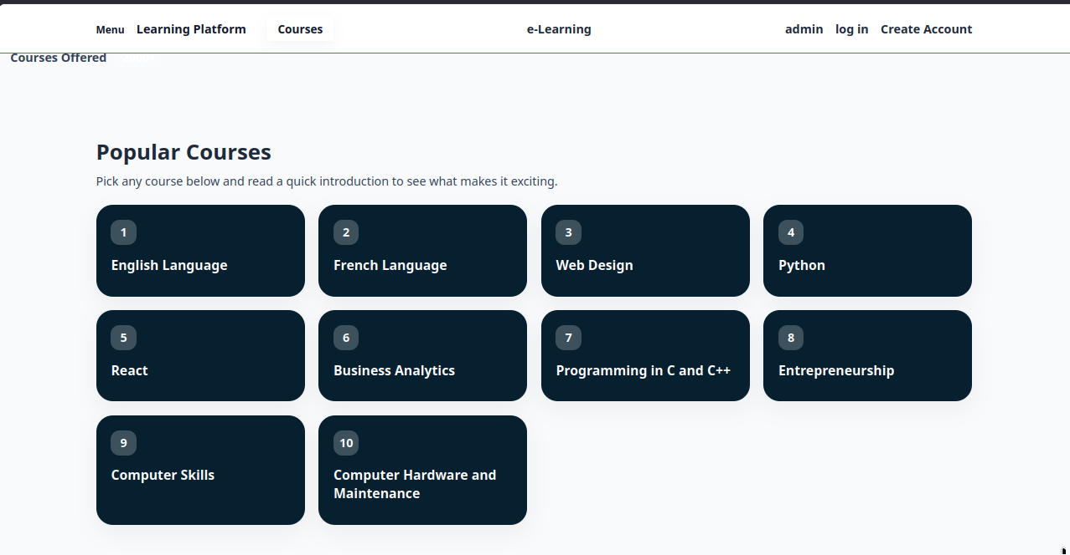

Chapter 4. Conclusion and Recommendation
Overall, the Campus Sync project achieved most of its stated objectives. [State here roughly what percentage of your objectives were achieved, e.g. "approximately 80% of the objectives were achieved"], with a working, responsive multi-page static website built using HTML, CSS and JavaScript.
Recommendations:

- To the lecturer: more practice time on responsive CSS layouts (Flex-box/Grid) would help beginner students build cleaner interfaces.
- To the school: the time given for this assessment was limited for a first project; more weeks would allow deeper polishing.
- To future partners: once a back-end is introduced, real course content and user accounts could be added.
- To the user: basic familiarity with navigating a website is enough to use Campus Sync comfortably.
- To the beneficiaries (students): Campus Sync can serve as a starting point before moving to more advanced learning platform.
APPENDIX
https.www.ceesalva.github.io/campus-syn

